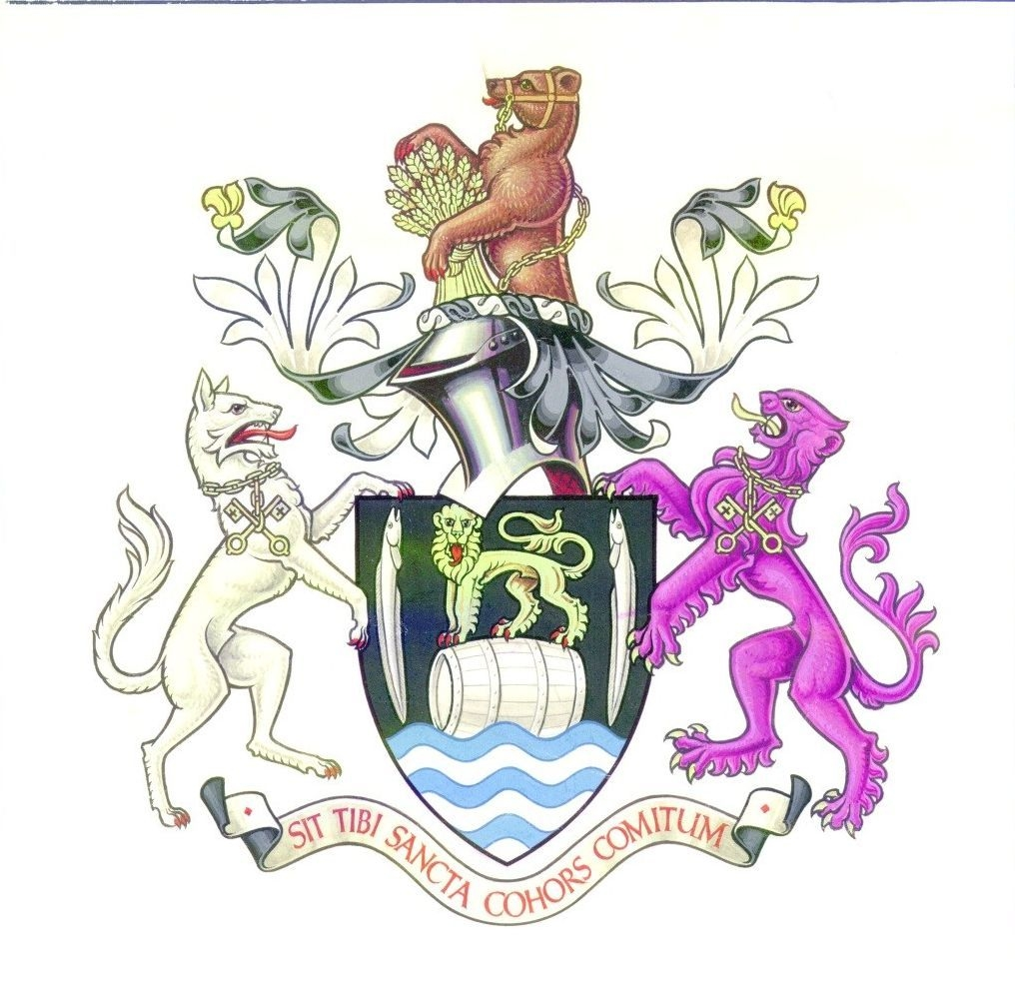

ANNUAL REPORT OF

CONGLETON TOWN COUNCIL

2009-10

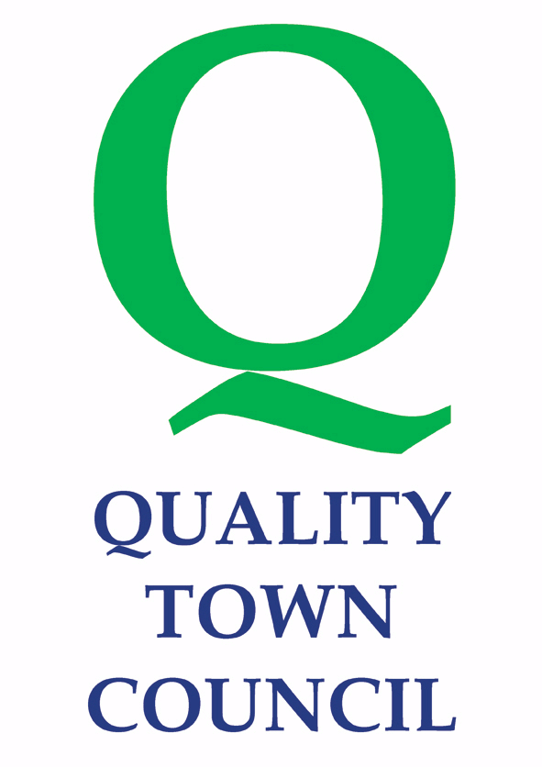

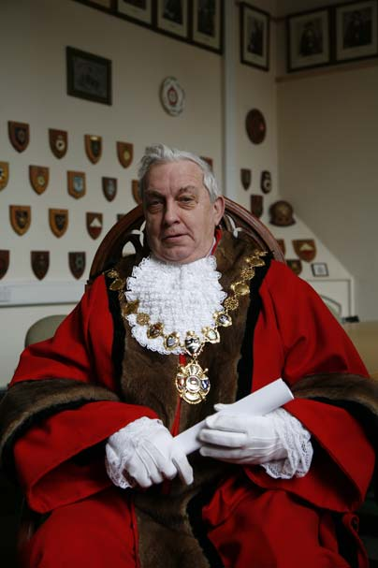
Mayor’s Overview
It’s been a busy, hectic and overall wonderful experience being your Town Mayor during 2009/10. Congleton is a hard working town, and during the past year my wife, Mayoress Joyce Clarke and myself have had the honour and privilege of meeting literally hundreds of people working quietly behind the scenes to ensure that Congleton remains a very special place in which to live, work and visit.
This is the first year that the Mayor of Congleton has had the support of a cadet. I thank my predecessor, Cllr Denis Murphy, for setting up the scheme. Rhiannon Horn, from the Air Training Corp has been incredibly professional and a real credit to Congleton and her organisation. Rhiannon has played a key role in many events including the Civic Service at St Peters, the Mayor’s Ball and laying a wreath for young people at the Remembrance Service. She has also accompanied us on many occasions.
I would like to thank the schools, clubs, organisations, companies and charities for the consistently warm welcome they have shown us. We have been so impressed with the amount of events and activities taking place in town and with the professionalism of our actors, musicians and performers. During the year we attended around 200 events – including Congleton’s first ever Food and Drink Festival and first official teddy bears’ picnic – both set to become annual events. We met Pudsey when he visited Congleton for Children in Need, and witnessed the Town gaining its 2nd Guinness World Record.
One of my first duties was to take a salute from members of the first battalion Mercian Regiment, the former Cheshires, during a freedom march through the town in June 2009. Some of the soldiers returned in November to help with the very successful Christmas Lights switch-on. As my mayoral office comes to an end the battalion is in Afghanistan, and on behalf of the town I wish them a safe tour and speedy return.
I was delighted to pick up a Neighbourhood Award for Buglawton from North West in Bloom and wish to recognise the hard work and dedication of Buglawton and Congleton in Bloom teams over the past 12 years. I wish them well in their ‘retirement’ and I am pleased that the Town Council will continue to make the Mountbatten by-pass bloom.
The next few years will see significant change in the town and it will be important that we all work together to make sure that changes can have a long lasting positive impact on the town.
The past three Town Mayors’ have concentrated on fund raising for young people, and so I have focused on the more mature generation. The older generation gives so much to the town that I wanted to give them something back. I am delighted to announce, with the help of many friends and organisations, I have raised more than £8,200 to be shared amongst charities and organisations helping mature groups.
I would like to finish by offering my sincere thanks to my predecessor Councillor
Denis Murphy, to my fellow councillors, to the staff at the Town Council, to Reverend Paul Withington and to everyone who has supported me and my charities over the past year.
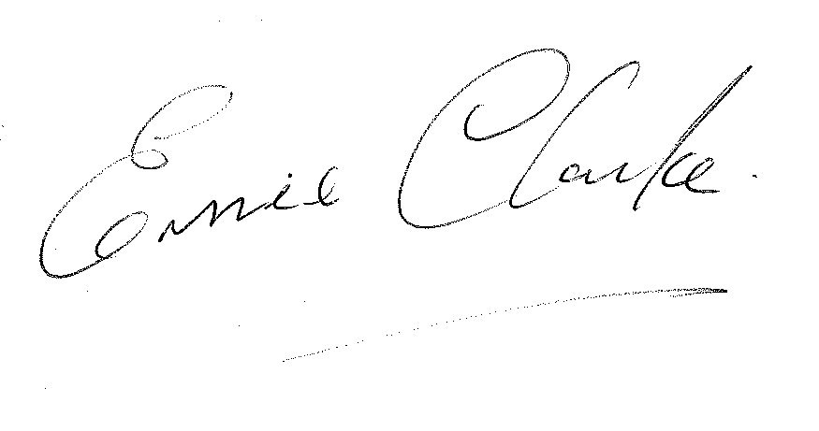
Cllr. E. Clarke

Leader of the Council

2009/10 has been a challenging year for the Town Council and the town. The start of the year saw the end of Congleton Borough Council and the birth of the larger Cheshire East Council. Councillors and staff at the Town Council have been working hard to establish new and better working relationships with the new authority and are in regular contact with its councillors and officers to promote the needs and concerns of Congleton as well as establishing a rebate for some double tax issues.

Throughout the year the Town Council has been liaising and commenting on major future projects for Congleton. A Task and Finish group was set to comment on the proposed Modus Development for Bridestones 2 Development. The Planning application was submitted by Modus in May, but the company subsequently went into administration and the plans are still waiting to be determined. The Town Council has also had meetings with the Clowes/Jameson Group about their alternative town centre ideas and with the Primary Health Care Trust about the Super Surgery proposals. The Town Council is the only council in the East Cheshire Chamber of Commerce, and is delighted that it is now located back in our town.

The renovation works on the Town Hall started in earnest, with the building covered in scaffolding from July to October 2009. The number of booking for the building has increased significantly over the year, but we still have a long way to go to bring down the deficit. The Bridestones Suite on the first floor is going through a complete transformation and once finished this should also attract significant bookings.

As the most local tier of government, the Town Council has been actively involved in with many groups working to improve conditions for people working and living in Congleton. We are very fortunate that we have such a strong Congleton Partnership, which has been successful in attracting funding and partners to take forward initiatives for the town such as the River Dane Walkway, the Abundance Project, the Micro business project and the town centre branding.

We had a change of Town Clerk during the year, with Ian Fynn retiring in November from a part-time Clerk’s position and Brian Hogan starting in December. With a full-time Town Clerk, a full compliment of Councillors and motivated staff we are in a strong position to face the challenges of the coming years.

Cllr. Nigel Bayley

The Town Council has 20 Councillors, who are elected to represent one of the six wards in the town. Councillors are elected to serve a period of four years. All seats are up for election in May 2011.

Buglawton | Central
Robert Boston (L) Clive Anstice (C)
Ernie Clarke (L) David Martin (C)
Douglas Parker (C) Jeanne Whitehurst (LD)
North North-West
Lisa Bossons (L) Gordon Baxendale (C)
Louise Daniels (C) Bob Edwards (C)
Andrew Thwaite (C) Chris Nield (C)
South West
David Brown (C) Nigel Bayley (C)
Sally-Ann Holland (C) Denis Murphy (LD)
Peter Mason (C) Phillip Smith (C)
Mathew Carey (C) Rebecca Williams (C)
C = Conservative, LD=Liberal Democrats L= Labour

Officers for the period of this annual report were:
- Town Clerk - Brian Hogan
- Support Manager – Jackie Potts
- Town Centre and Marketing Mrg - Jackie MacArthur
- Admin Assistant (Mayor and grants) - Linda Minshull
- Administrative Assistant – Sheron Clarke, Sue Trow
- Facilities Mgr - Chris Jones
- Handymen – Chris Banks, Mark Worthing
- 2 Halls Officers – Melvyn Hulme
- Casual Paddling Pool Attendants May – September
- Casual Bar and Caretaking Staff
- Change Management Consultant – Peter Cooper
- Architectural Consultant - David Dingle

Council Meetings

The Council has five committees, which each meet around 8 times a year. The dates for meetings in 2009/10 were

Amenities and Services 4/6 3/9 8/10 19/11 11/2 8/4

Community and Environment 4/6 3/9 9/10 19/11 11/2 25/3

Council 25/6 20/8 24/9 5/11 10/12 14/1
11/3 22/4

Finance and Policy 11/6 10/9 3/12 7/1 25/2 1/4

Planning 18/6 9/7 20/8 10/9 1/10 22/10 12/11
3/12 7/1 25/2 18/3 8/4

Town Hall Committee 9/7 1/10 12/11 18/3

Personnel Committee and Strategy Working Group are held as and when necessary.

How is the Town Council Financed?

The majority of the Town Council’s money comes from a precept which is added to the Council Tax levy set by the Principal Authority. In 2009-10 the precept was £580,863. Below is a summary of income for the year ending 31st March 2010.

The money is spent providing services and representing the people of Congleton. In broad terms in 2009-2010 the Town Council spent the money it raised on the following:

 |  |  |  |  |  | 2009/10 |  |  |  | 2008/9
Income |  |  |  |  |  | £ |  |  |  | £
Precept |  |  |  |  |  | 580,863 |  |  |  | 531,625
Capital Grants received (Town Hall) |  |  |  |  |  |  |  |  |  | 1,596,039
Loans received C East & PWLB (Town Hall) |  |  |  |  |  | 750,600
Interest and Investment income |  |  |  |  |  | 3,259 |  |  |  | 9,874
Community & Environment |  |  |  |  |  | 8,505 |  |  |  | 2,973
Corporate Management |  |  |  |  |  | 326 |  |  |  | 98
Town Hall |  |  |  |  |  | 99,513 |  |  |  | 89,223
Other Grants received |  |  |  |  |  |  |  |  |  | 700
Mayor's fundraising activities |  |  |  |  |  | 15,898 |  |  |  | 15,182
Congleton Partnership/Market Towns |  |  |  |  |  | 21,000 |  |  |  | 62,501
 |  |  |  |  |  | 1,479,964 |  |  |  | 2,308,215
Expenditure
Corporate Management |  |  |  |  |  | 172,140 |  |  |  | 145,017
Democratic Expenses |  |  |  |  |  | 42,107 |  |  |  | 35,963
Grants |  |  |  |  |  | 87,013 |  |  |  | 84,811
Mayor's fund raising grants and activities |  |  |  |  |  | 15,899 |  |  |  | 15,182
Capital Expenditure :
Town Hall; Allotments; Paddling Pool |  |  |  |  |  | 806,600 |  |  |  | 1,643,039
Operational Expenditure :
Paddling Pool |  |  |  |  |  | 20,961 |  |  |  | 22,872
Allotments |  |  |  |  |  | 943 |  |  |  | 1,524
Singleton in Bloom/Christmas Lights |  |  |  |  |  | 11,391 |  |  |  | 16,573
Christmas Fare |  |  |  |  |  | 4,411 |  |  |  | 3,450
Youth & Young People |  |  |  |  |  | 1,389 |  |  |  | 1,026
Tourism |  |  |  |  |  | 1,741 |  |  |  | 1,000
Handyman Services |  |  |  |  |  | 36,345 |  |  |  | 21,325
Highways Footpath & Lighting |  |  |  |  |  | 0 |  |  |  | 5,000
Shopmobility |  |  |  |  |  | 0 |  |  |  | 5,000
Town Hall |  |  |  |  |  | 133,750 |  |  |  | 131,104
Community & Home Safety |  |  |  |  |  | 41,468 |  |  |  | 43,580
Market Towns/Singleton Partnership |  |  |  |  |  | 45,544 |  |  |  | 89,194
Community Development |  |  |  |  |  | 25,442 |  |  |  | 16,916
Devolved Services |  |  |  |  |  | 5,000
 |  |  |  |  |  | 1,452,144 |  |  |  | 2,282,576
General Fund
Balance at 1st April |  |  |  |  |  | 128,447 |  |  |  | 102,808
Add: Total Income |  |  |  |  |  | 1,479,964 |  |  |  | 2,308,215
 |  |  |  |  |  | 1,608,411 |  | 0 |  | 2,411,023
Deduct: Total Expenditure |  |  |  |  |  | 1,452,144 |  | 0 |  | 2,282,576
 |  |  |  |  |  | 156,267 |  | 0 |  | 128,447
General Reserve Balance at 31st March |  |  |  |  |  | 156,267 |  | 128,447 |  | 128,447
The Town Council has supported local voluntary and community groups with nearly a £100,000 worth of grants in 2009-10

Among those assisted were:
£
Timbersbrook WI | Grant | 500
Congleton Baby Café | Grant | 500
St Peter's church | Grant towards heritage & maintenance | 3000
Congleton Disabled Action Group | Grant towards allotment tools | 500
Congleton Youth Project Ltd | Grant towards operating costs | 3000
Beartown Belles | Grant towards operating costs | 500
Congleton Anglers Society | Project at Goodwins Pool | 1500
Cheshire Police Youth Fishing Project | Summer fishing competitions | 600
CDVA | Volunteering for Young people project | 3815
CCP | Grant for Garden Festival | 1500
Dane Valley Scout Group | Grant towards building project | 1000
St James the Great | Improvements to heating system | 900
Victoria Mill Arts Group | Arts Centre Project | 450
Asbury Mere Trust | operating costs | 750
Congleton Youth Project Ltd | 09/10 projects | 1000
South Cheshire Samaritans | Promotional projects | 600
KISS Careers fair |  | 660
Holy Trinity Mossley | DDA works | 2000
Congleton Life Savers | Defibrillators AED's | 1000
Royal British Legion - Wreath | Wreath | 31.50
Home Start | Operating costs | 1000
Trinity Methodist Church | Christmas meals for elderly | 100
C&E Committee | Storage Cabinet | 3000
Energy Technology Trust | Hire of Town Hall | 105
Town Hall | Subsidised Use of Town Hall | 2708
Congleton Museum | Notional rent grant | 4500
Congleton Community Partnership | Grant | 9000
Cong Partnership | Rent | 1533
CAB | CAB Grant 09/10 | 34000
Xmas lights | Xmas lights | 9000
Carnival Committee | Carnival Committee | 3750
Congleton in Bloom | Floral displays. | 4500
St Peter's Church | Churchyard Maintenance | 2669
St Peter's Church | Clock maintenance | 191
 |  | £99,863

In addition the Mayor raised £8,200 through charity events held throughout his year in office. This money will be shared amongst charities and organsisations helping mature groups.

What Services does the Town Council Provide:

- We fund 50% of the cost of four Police Community Support Officers, without our contribution there would be none
- We operate a Handyman Service who are responsible for cleaning up a variety of areas around the Town, removing litter, graffiti, tidying open areas, clearing pathways and alleys anything to make the Town cleaner and tidier.
- We have a Market Town Manager who organises a variety of events in the Town as well as spending time promoting the Town and its businesses
- We are in the process of restoring and refurbishing the Town Hall which was inherited from Congleton Borough Council; this is costing £750,000 which is provided by way of a low cost Government loan.
- The Council returns approximately £100,000 per year to organisations within Congleton to support their various activities, including making a significant contribution to the Citizens Advice Bureau
- The Council provides Allotments
- The Paddling Pool is opened and annually and maintained
- All of our Councillors are volunteers and none have claimed any expenses to date
Congleton Town Council is the most local level of Government. It serves the town’s 28,000 residents by:
- Providing an essential link between town residents and Cheshire East Borough Council to ensure grass roots views are heard and considered.
- facilitating economic development and regeneration of the town
- examining all planning and licensing applications and giving opinions to the Borough Council on behalf of local residents
- managing a range of local services and facilities to benefit the town including the Town Hall, handy-man service, paddling pool and allotments
- Providing financial support to a variety of community groups and organisations which support the well-being of Congleton residents.

Some of the major achievements for 2009/10 include:

- High Street facing office facilities open Monday – Friday 9-5pm
- Part-funded Four Police Community Officers for the Town (£44k)
- Improvements to the interior of the Town Hall
- Produced quarterly Town Council and Community Newsletter (Bear Necessities)
- Continued and developed the well respected Town Handy Person Scheme
- Adopted a pioneering Protocol on local governance, to make services more accountable locally
- Held an Open day for Town Treasurers, Ancient Records and Town Tapestry
- Continued support for Fair Trade
- Financial support for a play area at Lower Heath
- Worked on promotion of the Town and the creation of the Beartown Brand
- Christmas Fayre and Lights Switch on ceremony
- Supported the World Record for the largest number of Frisbees thrown.
- Supported town events such as the Food and Drink Festival
- Developed a Delivery Strategy for the Town Plan
- Promoted Young Council event with prospective Parliamentary candidates for Congleton
- Continued to support an active Youth Committee to serve the Town
- Provided direct support to Congleton In Bloom, and Cheshire Pride Awards
- Commencement of Regeneration Strategy projects for the Town
- High Profile Congleton Partnership & liaison with businesses
- Town Centre Management
- Negotiating with Cheshire East on devolved services and partnership working
- Grants to businesses for training for those out of work
- Partnership funding for a play area
- Supported additional drop kerbs to help disabled access
- Had the Town Hall licensed as a Wedding Venue and negotiated for a commercial partner for catering and bar services
- Constructed a Tapas Bar in the Town Hall
- Recruited a Full Time Town Clerk

Some key initiatives for 2010-11 – taken from the Corporate Strategy are: -

An Active and Engaged Community
- To administer the community grant scheme to help support and develop local groups including CAB and CVS
- Support the Cheshire East Community Partnership in developing a Sustainable Community Strategy
- To operate openly and share information through the Town Council website, community newsletter, notice boards and the media.
- To continue to engage in the town’s next generation by supporting youth organisations & facilities and by working with the town’s Youth Councillor Committee.
- Support sport and leisure facilities which promote healthy lifestyles and support Team Congleton 2012 ‘s objective of building an indoor running track
- Support Congleton’s Food and Drink Festival and Best Garden Competition
- Support the continuation of Congleton’s Fair Trade Status
- Support the establishment of a Shop Mobility Scheme
A Sustainable Environment
- Continue the Town Handyperson service to keep on top of small works in the town.
- To directly support “In Bloom” initiatives in Congleton and Buglawton and the Community Pride Competition
- Re-establish clean teams to improve the cleanliness of the town
- Fund four Police Community Support Officers to work in the town and support the work of ShopWatch
- Be the voice of Congleton on licensing applications affecting the town
- Work with the Sustainability Group to produce a Town Energy Plan
- Take the first steps towards becoming a transitional town.
- Make the Town Hall more energy efficient.
- Support efforts to soften and green Mountbatten Way
- Support phases 2 and 3 of the River Dane Walkway to provide a green corridor across the town.
- Facilitate the production of a Public Realm Design Statement
A Celebrated and Protected Heritage
- Actively support the Management Plans for our Conservation Areas
- Work with parties to ensure that regeneration and new developments reflect the heritage and traditional architecture of the Town
- Be involved in management of Congleton Park
- Promote access to Town Treasures and Ancient Records and hold an Open Day
A Strong and Diverse Economy
- Deliver on the 22 action points in the Regeneration strategy.
- Support the setting up of a Business Enterprise Centre in Congleton
- Work with the KISS group and others to help local businesses
- Set up a Traders Group and work with them to help improve retail provision and the Market.
- Lobby for high quality employment sites and improvement of existing Business Parks
- Facilitate a Congleton Employment Land Study
- Provide Town Centre Management.
- Work with partners to utilize the Town’s entrepreneurial strength
- Will seek to identify Congleton as a disability friendly town
- Work with partners to promote Congleton through the Beartown Brand.
- Advocate for improved public transport links

You can contact Congleton Town Council by:

Visiting/writing to: Congleton Town Council, Congleton Town Hall, High Street, Congleton, CW12 1BN

Website: www.congleton-tc.gov.uk

Telephoning: 01260 270350

Fax: 01260 280357

Emailing: info@congletontowncouncil.co.uk

Published May 2010

