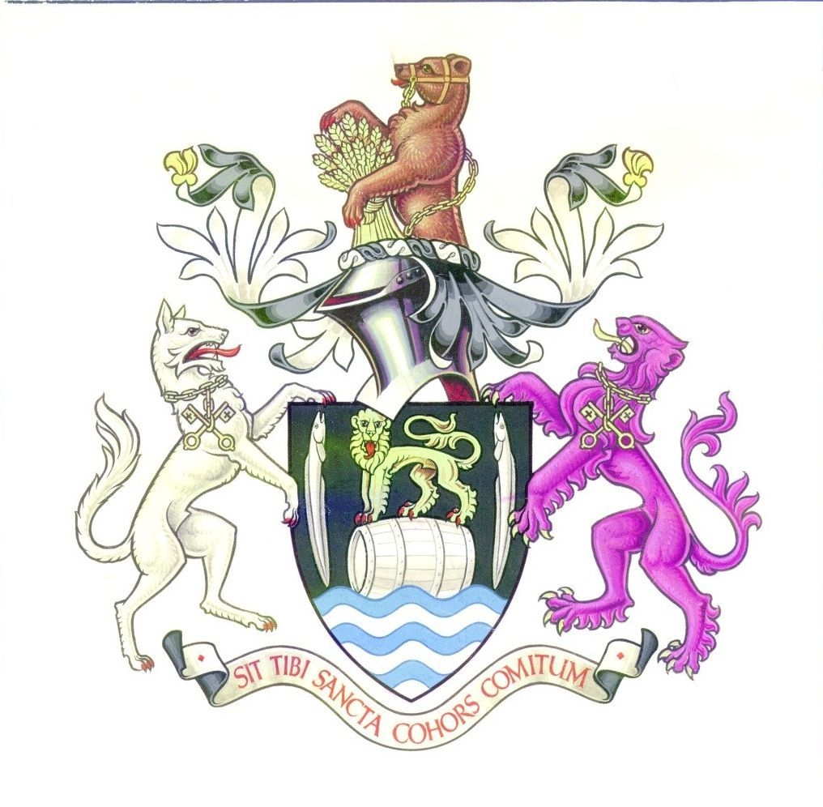

ANNUAL REPORT OF

CONGLETON TOWN COUNCIL

2008-9



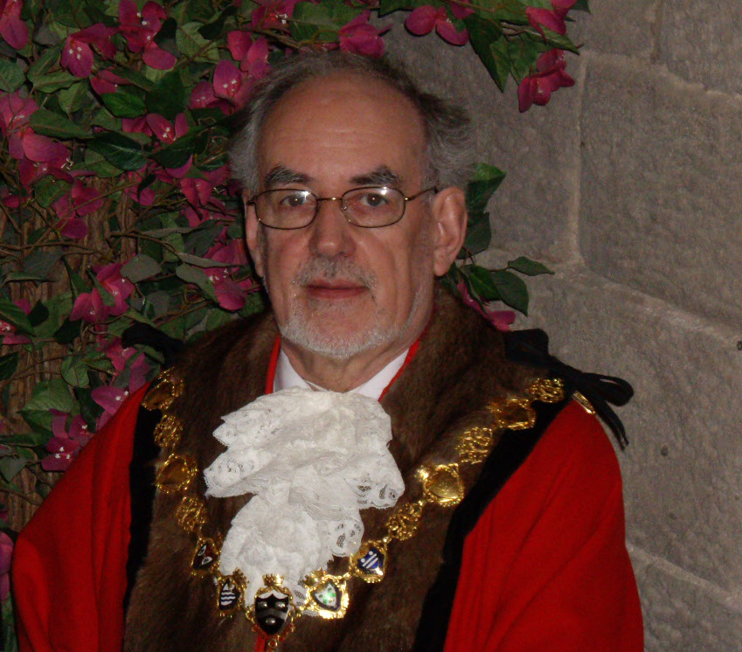
Mayor’s Overview 2008-2009 – Cllr Denis Murphy

It has been a real honour to serve as Congleton Town Mayor for 2008-9 and I honestly say that I cannot think of a better job! During the year the Mayoress, Joan Myatt, and myself have had the privilege of meeting hundreds of people from a wide variety of groups and organisations. We have constantly been impressed with the warm welcome we have received and the work and devotion of these groups and individuals.

It is the strength of our voluntary organisations and friendliness of our people that makes Congleton such a very pleasant place to live, work and visit. We have an army of volunteers who selflessly give their time and skills for the benefit of others. We are incredibly fortunate to have these people and to all 5000 + Congleton volunteers I offer you my thanks.
Young people have featured very strongly through my year in office. During the year the Town Council set up a Youth Committee. The 10 elected young people, aged 14-18, give an added dimension to our decision making and are a very welcome addition. Young people also helped Congleton secure a place in the record books this year, and one of my first tasks as Mayor was to preside at the Town’s successful attempt at the World’s largest Maypole Dance.
In June 2008 the Town Council took over the freehold and management of the Town Hall. The Town Council is committed to making the Town Hall the venue for Congleton – and plans have been drawn up for renovation and contracting a commercial partner to help meet this aspiration.
In September 2008 the Town Council was awarded Quality Council Status in recognition of the high standards achieved by the Council.
The tireless work of volunteers, especially the Congleton and Buglawton in Bloom teams, was largely to thank for the town gaining second place in the Cheshire Pride awards. These groups really help transform the town every summer. Thanks also to the Christmas Crackers team, who helped deliver our best switch-on celebration in years.
During the year I was privileged to either chair or be a guest at numerous meetings, conferences, and committees. These made me appreciate how hard people are working to improve the town – groups such as KISS (Knowledge, Information Sharing and Support) group, town traders, Congleton Partnership, the Branding Volunteers, Congleton Police and Team Congleton 2012 to name but a few. The town is going to be going through significant change and we all need to work together to make sure it has a long lasting positive effect.
I am delighted to announce that during my year I raised around £10,300 which will be divided amongst 23 youth sections of organisations in Congleton. Young people are the future of our town, and I am sure this funding will be well used. I thank these groups for their role in giving Congleton’s youth a good start.
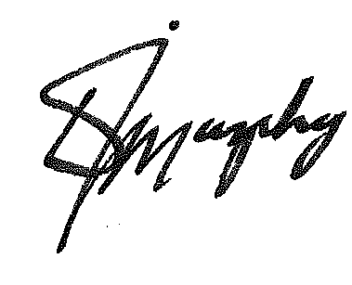
I would like to finish by offering my sincere thanks to my predecessor Councillor Douglas Parker, to my fellow councilors, to the staff at the Town Council and to everyone who has supported me and my charities over the past year. If I have one regret, it’s that my Mayoral year came to an end just before the Mercian Regiment (Cheshire’s) were due to march through the town, however I know my successor, Councillor Ernie Clarke will be a splendid Mayor, and I offer him every success as he takes over the best job in Congleton!

The Town Council has 20 Councillors, who are elected to represent one of the six wards in the town. Councillors are elected to serve a period of four years. All seats are up for election in May 2011.

Buglawton | Central
Robert Boston (L) (elected August 07) Clive Anstice (C)
Ernie Clarke (L) David Martin (C)
Douglas Parker (C) Jeanne Whitehurst (LD)
North North-West
Steven Burgess (L) (resigned Dec 2008) Gordon Baxendale (C)
Louise Daniels (C) Louise Beard (C) (I)(from Feb 2009)
Andrew Thwaite (C) Bob Edwards (C)
South West
David Brown (C) Nigel Bayley (C)
Sally-Ann Holland (C) Denis Murphy (LD)
Peter Mason (C) Phillip Smith (C)
Len McGarry (C) Rebecca Williams (C)
C = Conservative, LD=Liberal Democrats L= Labour I = Independent

Officers for the period of this annual report were:
- Town Clerk (18.5hrs)– Ian Fynn
- Support Manager (30 hrs)– Jackie Potts
- Town Centre and Marketing Mrg (27 hrs) Jackie MacArthur
- Admin Assistant (Mayor and grants) (18 hours)- Linda Minshull
- Administrative Assistant (20hrs) – Sheron Clarke
- Acting Facilities Mgr (Full Time) - Chris Jones
- Handyman (Full Time from Jan 2009) – Chris Banks
- 2 Halls Officers (26 ¾ hrs) – Melvyn Hulme, Ernie Sealy
- Casual Paddling Pool Attendants May – September
- Casual Bar and Caretaking Staff
- Change Management Consultant – Peter Cooper
- Architectural Consultant - David Dingle

Council Meetings

The Council has five committees, which each meet around 8 times a year. The dates for meetings in 2008/9 were

Amenities and Services 12/6 4/9 9/10 20/11 15/1 12/2 26/3

Community and Environment 12/6 4/9 9/10 20/11 15/1 12/2 26/3

Council 23/5 17/7 28/8 25/9 6/11 18/12 29/1
12/3 23/4

Finance and Policy 3/7 11/9 23/10 4/12 22/1 26/2 2/4

Planning 19/6 10/7 7/8 28/8 11/9 2/10 23/10 13/11
4/12 8/1 5/2 26/2 19/3 9/4

Town Hall Committee 9/7 1/10 12/11 18/3
Personnel Committee and Strategy Working Group are held as and when necessary.

How is the Town Council Financed?
The majority of the Town Council’s money comes from a precept which is added to the Council Tax levy set by the Principal Authority. In 2008-9 the precept was £531,625 Below is a summary of income for the year ending 31st March 2009.
Income |  |  | 2008/9 |  | 2007/8
Precept on Borough Council |  |  | 531,625 |  | 39,5000
Capital Grants received ( including Town Hall) |  |  | 1,596,039 |  | 0
Interest and Investment income |  |  | 9,874 |  | 18,020
Community & Environment |  |  | 2,973 |  | 500
Corporate Management |  |  | 98 |  | 293
Town Hall |  |  | 89,223
Other Grants received |  |  | 700
Mayor's Fundraising activities |  |  | 15,182 |  | 4773
Market Towns Partnership |  |  | 62,501 |  | 235,905
 |  |  | 2,308,215 |  | 654,491

The money is spent providing services and representing the people of Congleton. In broad terms in 2008-2009 the Town Council spent the money it raised on the following:
Expenditure |  |  | 2008/9 |  | 2007/8
Corporate Management |  |  | 145,741 |  | 114,705
Democratic Expenses |  |  | 37,962 |  | 33,016
S137 Expenditure |  |  | 16,186 |  | 6,528
Capital Expenditure :
Town Hall;Allotments;Paddling Pool |  |  | 1,641,754 |  | 2,610
Operational Expenditure :
Paddling Pool |  |  | 94,814 |  | 21,849
Allotments |  |  | 1,524 |  | 3,323
Congleton in Bloom/Christmas Lights |  |  | 16,573 |  | 5,343
Christmas Fayre |  |  | 3,450 |  | 1,535
Youth & Young People |  |  | 1,026
Tourism |  |  | 1,000
Handyman Services |  |  | 21,326 |  | 23,171
Highways Footpath & Lighting |  |  | 5,000 |  | 250
Town Hall |  |  | 134,986 |  | 8,900
Community & Home Safety |  |  | 44,080 |  | 39,720
Other Grants (under specific powers) |  |  | 78,422 |  | 79,501
Mayors fundraising grants and civic expenses |  |  | 15,181 |  | 4,819
Market Towns |  |  | 88,194 |  | 361,098
Community Development |  |  | 16,916 |  | 2,755
 |  |  | 2,364,135 |  | 709,123
General Fund
Balance at 1st April |  |  | 102,808 |  | 90,759
Add: Total Income |  |  | 2,308,215 |  | 65,4491
 |  |  | 2,411,023 |  | 745,250
Deduct: Total Expenditure |  |  | 2,364,135 |  | 709,123
 |  |  | 46,888 |  | 36,127
Transfer from Earmarked Reserves |  |  | 81,559 |  | 66,681
General Reserve Balance at 31st March 2009 |  |  | 128,447 |  | 102,808
The Town Council has supported local voluntary and community groups with more than £100,000 worth of grants in 2008-9

. Among those assisted were:

- Astbury Mere Trust
- Beartown Boxing Club –Equipment
- Beartown Patchers and Quilters's- 2 day exhibition
- Beartown Supporters Trust - Brown signs
- CDVA - Action Project funding
- Christmas Lights
- Cong Amateur Operatic Society -2008 production
- Cong Amateur Operatic Society -Guarantee to underwrite loss if occurs
- Congleton Carnival Committee
- Congleton Citizens Advice Bureau – towards running costs
- Cong Disabled Access Group -Promotional work
- Congleton in Bloom – displays across town
- Cong Lawn Tennis Club -Order of Play Board
- Cong Partnership -grant towards rent Jan-Mar
- Cong Pentecostal Church -Refurbishment of Church Hall
- Cong Youth Orchestra
- Cong Youth Projects -Additional grant
- Cong Youth Projects -Initial Grant
- Congleton Community Projects -grant towards rent Jan-Mar
- Congleton Community Projects -Grant Aid
- Congleton Coronation Bowling Club -Improvements to Club
- Congleton KISS Group -Careers Exhibition in Town Hall
- Congleton Partnership -Timbersbrook Picnic Site
- Congleton Rovers Junior Football Club - Secure storage facility
- Dial a ride - Contribution to update service
- DVASC - Equipment
- Friends of Cong Park -Band Concerts
- Friends of Cong Park -interactive workshops
- Regeneration Strategy -Regeneration Strategy
- Rode Hall Silver Band -Attending International event
- Ruby's fund -registration of charity
- Samaritans - Outreach work
- St Peter’s Church – maintenance of churchyard and clock
- The Friendship Club -Parties and Outings
- Trinity Methodist Church -Upgrade kitchen facilities

In addition the Mayor raised almost £10,300 through charity events held throughout his year in office. This money was divided amongst 23 youth sections of Congleton organisations.

Congleton Town Council is the most local level of Government. It serves the town’s 28,000 residents by:
- providing an essential link between town residents and Cheshire East Borough Council to ensure grass roots views are heard and considered.
- facilitating economic development and regeneration of the town
- examining all planning and licensing applications and giving opinions to the Borough Council on behalf of local residents
- managing a range of local services and facilities to benefit the town including the Town Hall, handy-man service, paddling pool and allotments
- providing financial support to a variety of community groups and organisations which support the well-being of Congleton residents.

Some of the major achievements for 2008/9 include:

- High Street facing office facilities open Monday – Friday 9-5pm
- Gained Quality Town Council Status
- Part-funded Four Police Community Officers for the Town (£44k)
- £70k improvements to the Town’s Paddling Pool
- Took over the freehold and management of the Town Hall.
- Completed and opened new allotments at Hillary Avenue
- Produced quarterly Town Council and Community Newsletter (Bear Necessities)
- Continued and developed the well respected Town Handy Person Scheme
- Adopted a pioneering Protocol on local governance, to make services more accountable locally
- Held an Open day for Town Treasurers, Ancient Records and Town Tapestry
- Worked on promotion of the Town and the creation of the Beartown Brand
- 4,500 + attended the Christmas Fayre and Lights Switch on ceremony
- Gained a World Record for the largest Maypole dance.
- Supported town events such as the Carnival & Garden Festival
- Developed a Delivery Strategy for the Town Plan
- Two active Young Council events for all Primary Schools
- Established an active Youth Committee to serve the Town
- Support to Congleton In Bloom, and runner-up in Cheshire Pride Awards
- Produced a Regeneration Strategy for the Town with 22 actions
- A Market Study and an Atmospheric Study was carried out through partnership
- Successfully lobbied to include Town Centre Area Action Plan in Cheshire East LDS
- High Profile Congleton Partnership & liaison with businesses
- Town Centre Management
- Grants to businesses for training (£2k)
- Had the Town Hall licensed as a Wedding Venue and negotiated for a commercial partner for catering and bar services
- Consulted on and adopted new Corporate Strategy – Backbone of the Community 2009-2012

Initiatives for 2009-2010

This next year will be a challenging one for the Town Council. The current Part-Time Town Clerk will retire in this financial year, and recruiting a strong full-time replacement will be essential. Cheshire East Borough Council only came into being on the 1 April 2009, and establishing new working relationships and partnerships is also key to the success of Town Council. Renovating the Town Hall is a major draw on resources, and establishing the Town Hall as a thriving community business is another necessary challenge.

Some key initiatives for 2009/10 – taken from the Corporate Strategy are: -

An Active and Engaged Community
- To administer the community grant scheme to help support and develop local groups including CAB and CDVA
- Support Congleton Now 2009 - a promotional exhibition for local voluntary and community groups to be held in September
- To operate openly and share information through the Town Council website, community newsletter, notice boards and the media.
- To engage the town’s next generation by supporting youth organisations & facilities and by working with the town’s Youth Councillor Committee.
- Support sport and leisure facilities which promote healthy lifestyles and support Team Congleton 2012
- Support Congleton’s first Food and Drink Festival and second Garden Festival
- Support the continuation of Congleton’s Fair Trade Status
A Sustainable Environment
- Continue the Town Handyperson service to keep on top of small works in the town.
- To support “In Bloom” initiatives in Congleton and Buglawton and the Community Pride Competition
- Re-establish clean teams to improve the cleanliness of the town
- Fund four Police Community Support Officers to work in the town and support the work of ShopWatch
- Be the voice of Congleton on licensing applications affecting the town
- Lobby for road safety improvement schemes for the town.
- Take the first steps towards becoming a transitional town.
- Make the Town Hall more energy efficient.
- Support efforts to soften and green Mountbatten Way
- Support phases 2 and 3 of the River Dane Walkway to provide a green corridor across the town.
A Celebrated and Protected Heritage
- Lobby for an arts and cultural centre in the town
- Actively support the Management Plans for our Conservation Areas
- Work with parties to ensure that regeneration and new developments reflect the heritage and traditional architecture of the Town
- Be involved in management of Congleton Park
A Strong and Diverse Economy
- Start to deliver on the 22 action points in the Regeneration strategy.
- Work with Cheshire East Recession Task Group to help benefit Congleton’s businesses
- Support the setting up of a Business Enterprise Centre in Congleton
- Work with the KISS group and others to help local businesses
- Set up a Traders Group and work with them to help improve retail provision and the Market.
- Lobby for high quality employment sites.
- Provide Town Centre Management.
- Lobby for the best possible deal for Congleton regards future changes in parking
- Work with partners to utilize the Town’s entrepreneurial strength
- Will seek to identify Congleton as a disability friendly town
- Work with partners to develop a clear brand for Congleton and 20 Business Ambassadors to represent the Town.

You can contact Congleton Town Council by:

Visiting/writing to: Congleton Town Council, Congleton Town Hall, High Street, Congleton, CW12 1BN

Website: www.congleton-tc.gov.uk

Telephoning/faxing: 01260 270350

Emailing: info@congletontowncouncil.co.uk

published May 2009

