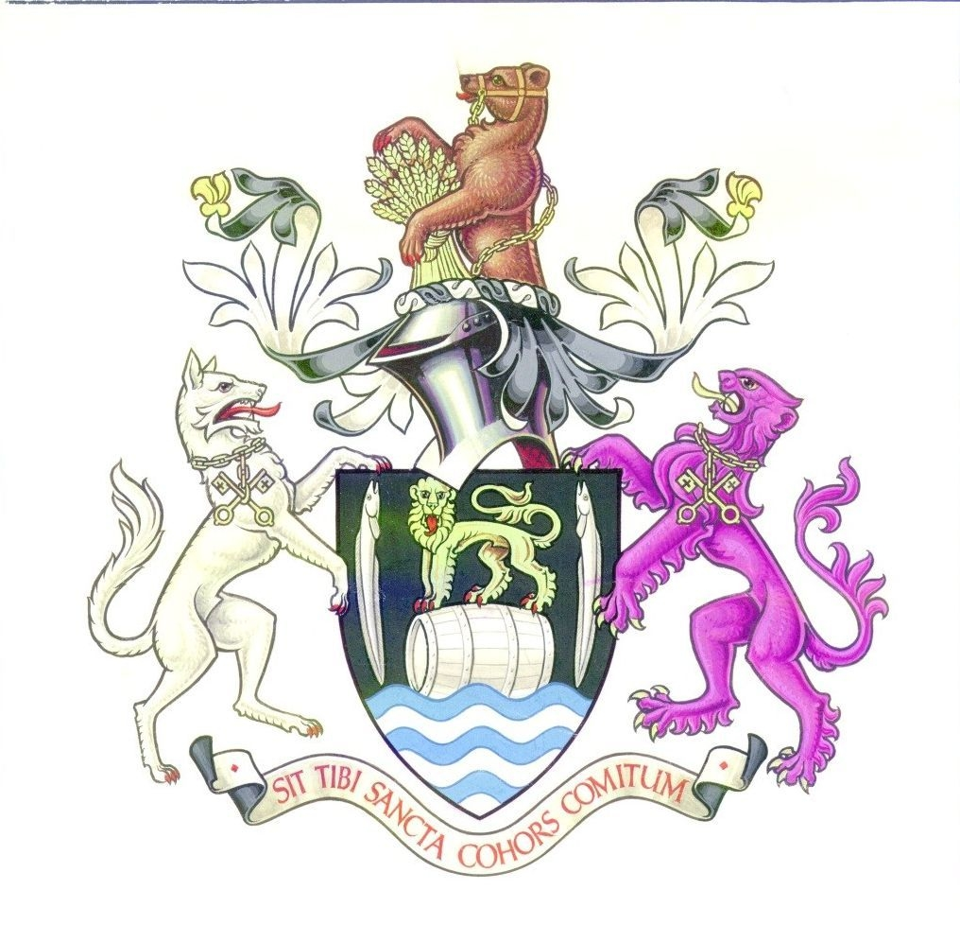

ANNUAL REPORT OF

CONGLETON TOWN COUNCIL

2007-8

Mayor’s Overview 2007-2008 – Cllr Douglas Parker

Although this was my third time as Town Mayor, the thrill and pleasure of serving the town was not at all diluted. During the year I had the privilege of meeting hundreds of people from a vast range of organisations operating in and around our town.

One of the things which always impresses me, whether it’s a voluntary group, school, business or 100th birthday, is how friendly people are in Congleton. It was a real pleasure to meet so many friendly people who care so much about our town and each other.

It is the strength of our voluntary organisations and friendliness of our people that makes Congleton such a very pleasant place to live, work and visit. We have an army of volunteers who selflessly give their time and skills for the benefit of others. This is what makes Congleton so special.

I had the good fortune to serve as Mayor in another very exciting year for Congleton.

We represented the North West in the Britain in Bloom awards and won a Silver medal. We also won North West in Bloom and the Cheshire Community Pride award for large towns. Many congratulations and thanks to the Congleton in Bloom and Buglawton in Bloom teams for the fantastic and tireless work they put into the town every year to make it so attractive.

The year saw a great deal of action with the Congleton Market Town Initiative and the town benefited from new town entry signs, new finger-posts and notice-boards, a much improved River Dane Walk way from Pavilion Bridge to Mill Bridge and the transformation of the second floor of the town hall from dusty hole to two modern offices.

A new Town Centre Plan was agreed at the end of my term as Mayor, and following a mandate from local people leaned towards transformational change for Congleton. Interesting and exciting times lie ahead as Congleton strives to make itself an even better place to live, visit and work.

One of my last duties was to receive the keys for the Town Hall from the Borough Council when the Town Council signed the contract to take over the freehold and management of the Town Hall from 2 June. As someone who organises lots of events, I am very much looking forward to seeing the promised improvements and life breathed back into our fantastic Town Hall.

I am delighted to announce that during my year I raised £6,600 which will be divided amongst the various scouting and guiding groups in the town, Congleton Air Training Corp, Congleton Youth in Action and Congleton Youth Orchestra. Young people are the life-blood of town. It is very exciting to know that in the next year there will be a formally elected Youth Council working with the Town Council.

I would like to finish by offering my most sincere thanks to my predecessor Councillor Louise Beard and successor Councillor Denis Murphy, to the staff at the Town Council and to everyone who has supported me and my charities over the past year.

The Town Council has 20 Councillors, who are elected to represent one of the six wards in the town. Councillors are elected to serve a period of four years. All seats were up for election in May 2007.

Buglawton | Central
Robert Boston (L) (elected August 07) Clive Anstice (C)
Ernie Clarke (L) David Martin (C)
Douglas Parker (C) Jeanne Whitehurst (LD)
North North-West
Steven Burgess (L) (co-opted January 2008) Gordon Baxendale (C)
Louise Daniels (C) Louise Beard (C)
Andrew Thwaite (C) Bob Edwards (C)
South West
David Brown (C) Nigel Bayley (C)
Sally-Ann Holland (C) Denis Murphy (LD)
Peter Mason (C) Phillip Smith (C)
Len McGarry (C) Rebecca Williams (C)

C = Conservative, LD=Liberal Democrats L= Labour

Officers for the period of this annual report were:
- Town Clerk (18.5hrs)– Ian Fynn
- Finance Officer (7.5 hrs)– Jackie Potts
- Admin Assistant (12 hours) - Jackie MacArthur
- Communications and Marketing (12 hours) Jackie MacArthur
- Admin Assistant (Mayor and Accounts) (18 hours)- Linda Minshull
- Town Handy Person (full time) - Chris Jones
- Casual Paddling Pool Attendants May – September
- Change Management Consultant – Peter Cooper
- Architectural Consultant - David Dingle

Council Meetings

The Council has five committees, which each meet around 8 times a year. The dates for meetings in 2008/9 are

Amenities and Services 12/6 4/9 9/10 20/11 15/1 12/2 26/3

Community and Environment 12/6 4/9 9/10 20/11 15/1 12/2 26/3

Council 23/5 17/7 28/8 25/9 6/11 18/12 29/1
12/3 16/4

Finance and Policy 3/7 11/9 23/10 4/12 22/1 26/2 2/4

Planning 19/6 10/7 28/8 11/9 2/10 13/11 4/12
8/1 5/2 19/3 9/4
Town Hall Committee 19/6 7/8 2/10 8/1 19/3
Personnel Committee and Strategy Working Group are held as and when necessary.

How is the Town Council Financed?

The majority of the Town Council’s money comes from a precept which is added to the Council Tax levy set by Congleton Borough Council. In 2007-8 the precept was £395,000. Below is a summary of income for the year ending 31st March 2008.

INCOME 2007/8 2006/7
£ £

Precept on Borough Council 395,000 360,000
Interest and Investment Income 18,020 12,304
Market Towns Partnership 235,905 29,600
Corporate Management 293 430
Mayor’s Fundraising Activities 4,773 11,966
Grants for Town Records - 5,000
Christmas Fayre 500 1,744
--------------- ------------
654,491 421044

The money is spent providing services and representing the people of Congleton. In broad terms in 2006-2007 the Town Council spent the money it raised on the following:

EXPENDITURE 2007/8 2006/7

Corporate Management 114,705 117,187
Democratic Expenses 33,016 7,146
S137 Expenditure 6,528 24,459
Capital Expenditure 5,365 12,250
Operational Expenditure
Paddling Pool 21,849 19,188
Churchyard and Church Clock 3,505 3,466
Congleton in Bloom/Christmas Lights 5,343 19,840
Handy Person Service 23,171 7,400
Other Grants (specific powers) 75,996 56,984
Mayor’s fundraising Grants and civic expenses 4,819 15,196
Market Town Initiative 361,098 43,254
Propagation Unit - 18,000
Town Hall 12,223 2,274
Highway Street Furniture 250 2,250
Community and Home Safety 39,720 1,001
Christmas Fayre 1,535 2,504

709,123 352,399
General Fund
Balance at 1st April 90,759 77,577
Add: Total Income 654,491 421,044
745,250 498,621
Deduct : Total Expenditure -709,123 -352,399

36,127 146,222

Transfer from/to Earmarked reserves 66,681 -55,463 General Reserve Balance at 31st March 102,808 90,759

The Town Council has supported local voluntary and community groups with more than £100,000 worth of grants in 2007-8. Among those assisted were:

- 1st Congleton Boy's Brigade - Bus Repair
- 1st Congleton Scouts - Flood defence project
- 230 squadron ATC - Minibus replacement
- Astbury Mere Trust - Dev Grant
- Astbury Mere Trust,
- Beartown Belles - Attending Championships
- Blackfirs School - Vegetable Garden
- Boalloy Running Club - operational costs
- Bromley Farm Community Project - drinking water fountain
- Bromley Farm Commuity Project - Disabled access
- Buglawton Friendship Group, - Christmas Party
- Buglawton Scouts - Roof repairs
- CAOS, 42nd Street
- Carnival Committee
- Charlotte Skellern (Scout Jamboree)
- Christmas lights
- Cong Cloud District Guides Garage for equipment storage
- Cong Cricket Club-bowls section, irrigation scheme for bowling green
- Cong Dist Voluntary Action, Drop in Centre
- Cong Dist Voluntary Action, Licence for grant finder software
- Cong Fair Trade Group, Annual costs
- Cong Lifelong Learning Partnership, Careers Fair
- Cong Park Bowling Club, Disabled steps at club entrance
- Congleton Choral Society Staging blocks
- Congleton Citizens Advice Bureau
- Congleton Community Projects, Congleton Garden festival
- Congleton Community Projects, Grant Aid
- Congleton in Bloom, Floral displays.
- Congleton Museum, Historical town survey
- Congleton Town FC Floodlighting
- Congleton Youth Orchestra
- Dane Valley Scout Group ,Car Park
- Friends of Congleton Park, Brass Band Events
- Global Link (to put on a display at Astbury Mere
- Mossley Old School Trust Disabled toilets/ heating
- Neuromuscular Centre, Long legs garment
- Our Gang – the Gang Show
- Radnor Park Scheme
- Samaritans, Promoting work of Samaritans
- Somerford kindergarten, Electrical work CCTV
- SSAFA, to help ex service personnel

In addition the Mayor raised £6,600 through charity events held throughout his year in office. This money was divided amongst various Congleton scouting and guiding groups as well as Congleton Air Training Corps, Congleton Youth Orchestra and Congleton Youth Project.

Congleton Town Council is the most local level of Government. It serves the town’s 29,000 residents by:

● facilitating economic development and regeneration of the town

● providing an essential link between town residents and the borough and county councils to ensure grass roots views are heard and considered.

● examining all planning and licensing applications and giving opinions to the Borough Council on behalf of local residents

● managing a range of local services and facilities to benefit the town including the handy-man service, paddling pool and allotments

● providing financial support to a variety of community groups and organisations which support the well-being of Congleton residents.

Some of the major achievements for 2007/8 include:

- Increased the office opening hours in the Town Hall.

- With the help of partners, produced a Town Centre Plan.

- Introduced a part-time Town Centre Manager.

- Continued the Town Handy Person Service which has helped keep the Town’s Public Realm clean and well maintained.

- Provided £44,000 funding for four Police Community Support Officers for the Town.

- Paid for the Town’s Christmas Lights and held a busy Christmas Fayre.

- With our partners, provided the new, disability compliant, River Dane Walkway.

- With Congleton Partnership provided new Town entry signs, fingerposts and notice boards.

- Supported the very successful Congleton in Bloom initiative.

- Lobbied for affordable housing and new employment sites

- Lead a Young Councillor event to introduce junior school pupils to the operations of a Council.

- Produced four issues of Bear Necessities Newsletter

- Helped maintain Fair Trade Status for the Town

- Gained an ADEPT Plus award for quality management procedures.

- Undertaken an environmental audit on the operation of the Council.

- Exchanged contracts with Congleton Borough Council to transfer the Town Hall to the Town Council in June 2008. Converted a second floor area into office use, with the aid of a Rural Enterprise Grant.

- Launched a new website www.congleton-tc.gov.uk

- Let a contract for the development of new allotments on Hillary Avenue, to include areas for the disabled and young people.

- Let a contract for the improvements to the Paddling Pool including new toilet/changing facilities.

Initiatives for 2008-2009: Below are some of the key initiatives for the coming year, taken from the corporate strategy.

A strong community spirit

- To administer the community grant scheme.

- Support a promotional exhibition for local voluntary and community groups.

- To take over the freehold and management of Congleton Town Hall and improve its facilities for the voluntary/community sector.

- To produce four editions of the Town Council/ Community newsletter.

- Work with Congleton CAB and CDVA and to support financially.

- To help businesses to improve accessibility.
- To engage the town’s next generation by supporting youth organisations & facilities.

- To introduce a Youth Councillor Committee in 2008

- Support sport and leisure facilities which promote healthy lifestyles

- To hold an Open Day for the Town Treasures and reframe the Town Tapestry.

- Improve/maintain the Park Play area.

- Open an allotment site and establish an allotment association.

- Hold a Maypole Dance World Record
Attempt.

- Deliver a home safety campaign.

- Promote Fair Trade in the Town.

- Lobby for affordable housing

A Sustainable Environment

- Continue the Town Handyperson service to keep on top of small works in the town.

- To support “In Bloom” initiatives in Congleton and Buglawton and the Community Pride Competition.

- To maintain the clean teams to improve the cleanliness of the town

- Support local heritage by grant aid
- Be involved in management of Congleton Park

- Fund four Police Community Support Officers to work in the town

- Be the voice of Congleton on licensing applications affecting the town

- Lobby for road safety improvement schemes for the town.

- Undertake an environmental awareness campaign.

- Make the town hall more energy efficient.
A robust economy

- Introduce a Town Council Website.

- Deliver a regeneration strategy.

- Continue to lobby for a Bypass and improved local transport

- Work to improve retail provision & the Market

- Lobby for high quality employment sites.

- Support the Carnival and a Garden Festival.

- To secure a draft Area Action Plan.

- Arrange skills development for leisure and retail businesses.

- Develop Town Centre Management.

You can contact Congleton Town Council by:

Visiting/writing to: Congleton Town Council, Congleton Town Hall, High Street, Congleton, CW12 1BN

Website: www.congleton-tc.gov.uk

Telephoning/faxing: 01260 270350

Emailing: info@congletontowncouncil.co.uk

published June 2008

