11th June 2009

Dear Councillor,

Planning Committee Meeting – Thursday 18th June 2009

You are requested to attend a meeting of the Planning Committee to be held in the Town Hall, High Street, Congleton, on Thursday 18th June 2009 commencing at 7.15 pm.

The Public and Press are welcome to attend the meeting. There may be confidential items towards the end of the meeting which the law requires the Council to make a resolution to exclude the public and press.

Yours sincerely,

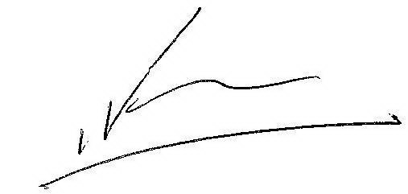

Ian Fynn
TOWN CLERK

AGENDA

1. Apologies for absence.(Members are reminded of the necessity to give apologies in
advance of the meeting and to give reasons for absence)

2. Minutes of Last Meeting

To confirm the minutes of the Meeting of the Committee held on 21st May 2009 (copy enclosed)

3. Declarations of Interest

Members are requested to declare both “personal” and “personal and prejudicial”
interests as early in the meeting as they become known.

- Outstanding Actions

None
5. Planning Applications

To make observations as may be necessary on planning applications submitted to Cheshire East Borough Council.

NOTE i) Lists for weeks ending 22nd and 29th May 2009 are enclosed.
ii) Lists for the weeks ending 5th and 12th June 2009 will be circulated at the meeting when received.

6. Planning Appeals

To note or comment as appropriate on planning appeals lodged or decided.

7. Licensing Applications

To note or comment as appropriate on licensing applications lodged with Cheshire East Borough Council.

N.B. Under the agreed procedure the Licensing Register is
updated weekly on the Web site and the Town Council has 28 days
from the date of the application to comment on new applications.

8. Highways Issues

To consider consultations received on the following highways matters and others which may be received before the meeting:-

9. Report by the Change Management Consultant –Dealing with Development Control and other Planning matters.

To consider the enclosed report including Appendix 5 by the Change Management Consultant.

10. Any Other Business

11. Resolution to exclude the Public and Press (if necessary)

To consider passing a resolution if required in accordance with the Public Bodies (Admission to Meetings) Act 1960, that public and press be excluded from the meeting for the matters set out below on the grounds that it could involve the likely disclosure of private and confidential information or staff matters.

To: Members of the Council, Press 3, Burgesses 5.

